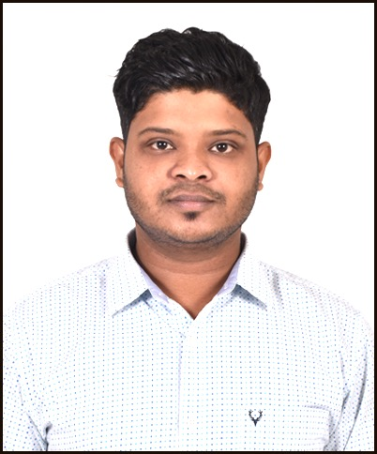
GOURAB CHOWDHURY
Contact: +919123668548/+88018167476057. Mail : gourab.chy@gmail.com
Notes : For details visit https://www.linkedin.com/in/gourab-chowdhury-5598613b/

(CIVIL ENGINEER)

Academic
QUALIFICATION | NAME OF INSTITUTE | BOARD | YEAR | PERCENTAGE
BE(CIVIL) | Sathyabama  University  (CHENNAI) | UGC | 2013 | 76%(1st class with distinction)

Engineering Skills

Structural  Analysis | Construction techniques | Design &  Drawing | Engineering Survey | Estimation | Site  Inspection | Auto-Cad  2D-3D
20% | 50% | 50% | 50% | 30% | 90% | 80%
Revit | Staad Pro | Photoshop | Tower ERC/DIS | Quality  controll | Piling | R.C.C
20% | 20% | 50% | 70% | 90% | 30% | 80%

Career History
Company | Duration | Role | Resposibilities | Client
Ho Brothers  Holdings LTD.  (Myanamr) | MAY 2018 to  Till Now | Tech Support  Officer(Civil) | Techinical support  of Civil & O&M  Projects | Telenor  Mytel  E.Co
Mobicon Networks  (Myanamr) | JAN 2016 to  JUNE 2017 | Acceptance  Manager | Acceptace & Quality  Assurence of telecom towers,Construction | ZTE
GTL International  (Myanamr) | JUNE 2014 to  DEC 2015 | Cluster Lead | Supervisio of telecomtowers &Construction | Apollo  MTC  Huawei  IGT
Toshniwal Enterprise  Pvt Ltd (Myanamr) | JAN 2014 to  MAY 2014. | Project  Coordinator | Coordination of Civil Construction &  Documentation | MTC
Unicon Construction  (India) | SEP 2012 to  JAN 2014 | Site Engineer | Building site  Inspection ,Autocad  drafting | N/A

